2019 Water Quality Report for Cadgewith Farms

This report covers the drinking water quality for Cadgewith Farms for the 2019 calendar year. This information is a snapshot of the quality of the water that we provided to you in 2019. Included are details about where your water comes from, what it contains, and how it compares to Environmental Protection Agency (EPA) and state standards.

Your water comes from 2 groundwater wells, each over 400 ft deep. The State performed an assessment of our source water to determine the susceptibility or the relative potential of contamination. The susceptibility rating is on a seven-tiered scale from "very-low" to "very-high" based on geologic sensitivity, well construction, water chemistry and contamination sources. The susceptibility of our source is low.

There are no significant sources of contamination in our water supply. We are making efforts to protect our sources by participating in the Michigan wellhead protection program.

If you would like to know more about the report, please contact our office 2300 East State rd Lansing, MI 48906 at 517-371-1101 or email us at Cadgewithfarm@gmail.com.

- Contaminants and their presence in water: Drinking Water, including bottled water, may reasonably be expected to contain at least small amounts of some contaminants. The presence of contaminants does not necessarily indicate that water poses a health risk. More information about contaminants and potential health effects can be obtained by calling the EPA’s Safe Drinking Water Hotline (800-426-4791).

- Vulnerability of sub-populations: Some people may be more vulnerable to contaminants in drinking water than the general population. Immuno- compromised persons such as persons with cancer undergoing chemotherapy, persons who have undergone organ transplants, people with HIV/AIDS or other immune systems disorders, some elderly, and infants can be particularly at risk from infections. These people should seek advice about drinking water from their health care providers. EPA/CDC guidelines on appropriate means to lessen the risk of infection by Cryptosporidium and other microbial contaminants are available from the Safe Drinking Water Hotline (800-426-4791).

- Sources of drinking water: The sources of drinking water (both tap water and bottled water) include rivers, lakes, streams, ponds, reservoirs, springs, and wells. Our water comes from wells. As water travels
over the surface of the land or through the ground, it dissolves naturally-occurring minerals and, in some cases, radioactive material, and can pick up substances resulting from the presence of animals or from human activity.

Contaminants that may be present in source water include:
  - Microbial contaminants, such as viruses and bacteria, which may come from sewage treatment plants, septic systems, agricultural livestock operations and wildlife.
  - Inorganic contaminants, such as salts and metals, which can be naturally-occurring or result from urban stormwater runoff, industrial or domestic wastewater discharges, oil and gas production, mining or farming.
  - Pesticides and herbicides, which may come from a variety of sources such as agriculture and residential uses.
  - Radioactive contaminants, which can be naturally occurring or be the result of oil and gas production and mining activities.
  - Organic chemical contaminants, including synthetic and volatile organic chemicals, which are by-products of industrial processes and petroleum production, and can also come from gas stations, urban stormwater runoff, and septic systems.
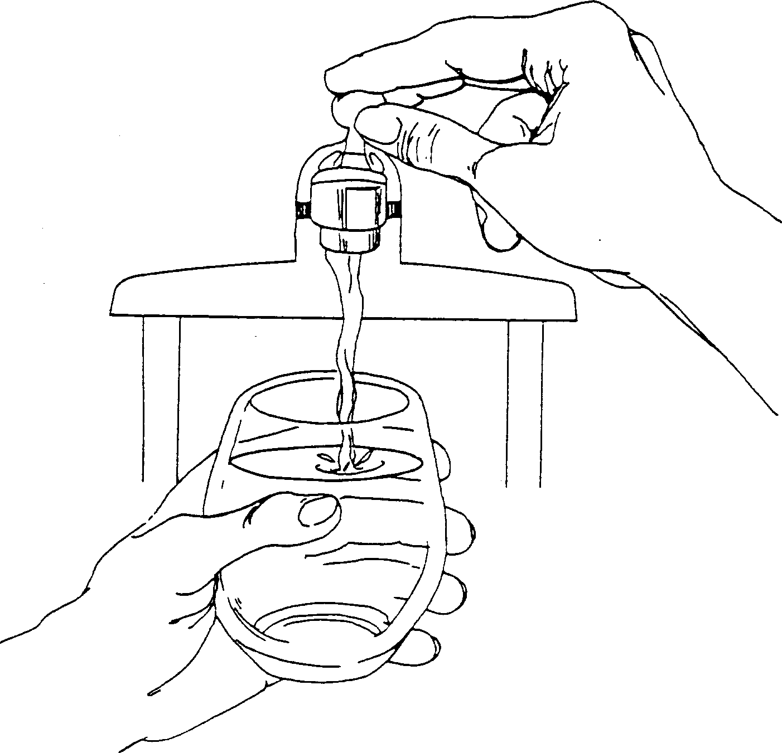

In order to ensure that tap water is safe to drink, EPA prescribes regulations that limit the amount of certain contaminants in water provided by public water systems. Food and Drug Administration regulations establish limits for contaminants in bottled water which provide the same protection for public health.

Water Quality Data
The table below lists all the drinking water contaminants that we detected during the 2019 calendar year. The presence of these contaminants in the water does not necessarily indicate that the water poses a health risk. Unless otherwise noted, the data presented in this table is from testing done January 1 – December 31, 2019. The State allows us to monitor for certain contaminants less than once per year because the concentrations of these contaminants are not expected to vary significantly from year to year. All of the data is representative of the water quality, but some are more than one year old.

Terms and abbreviations used below:
- Maximum Contaminant Level Goal (MCLG): The level of a contaminant in drinking water below which there is no known or expected risk to health. MCLGs allow for a margin of safety.
- Maximum Contaminant Level (MCL): The highest level of a contaminant that is allowed in drinking water. MCLs are set as close to the MCLGs as feasible using the best avalable treatment technology.
- Maximum Residual Disinfectant Level (MRDL): The highest level of a disinfectant allowed in drinking water. There is convincing evidence that addition of a disinfectant is necessary for control of microbial contaminants.
- Maximum Residual Disinfectant Level Goal (MRDLG): The level of a drinking water disinfectant below which there is no known or expected risk to health. MRDLGs do not reflect the benefits of the use of disinfectants to control microbial contaminants.
- Treatment Technique (TT): A required process intended to reduce the level of a contaminant in drinking water.
- N/A: Not applicable
- ND: not detectable at testing limit
- ppb: parts per billion or micrograms per liter
- ppm: parts per million or milligrams per liter
- pCi/l: picocuries per liter (a measure of radioactivity).
- Action Level (AL): The concentration of a contaminant which, if exceeded, triggers treatment or other requirements that a water system must follow.
- Level 1 Assessment: A study of the water supply to identify potential problems and determine (if possible) why total coliform bacteria have been found in our water system.
- Level 2 Assessment: A very detailed study of the water system to identify potential problems and determine (if possible) why an E. coli MCL violation has occurred and/or why total coliform bacteria have been found in our water system on multiple occasions.

Regulated Contaminant | MCL, TT, or MRDL | MCLG or MRDLG | Level Detected | Range | Year Sampled | Violation Yes/No | Typical Source of Contaminant
Nitrate (ppm) | 10 | 10 | ND | 0.4-10 | 2019 | No | Runoff from fertilizer use; Leaching from septic tanks, sewage; Erosion of natural deposits
Fluoride (ppm) | 4 | 4 | 0.46 | 0.1-4.0 | 2019 | No | Erosion of natural deposits; Water additive which promotes strong teeth; Discharge from fertilizer and aluminum factories
Sodium (ppm) | N/A | N/A | 11 | 5 | 2019 | No | Erosion of natural deposits
Hardness as CaCO3 | N/A | N/A | 236 | Non regulated | 2019 | No | Erosion of natural deposits
Chloride | N/A | N/A | ND | Non regulated | 2019 | No | Erosion of natural deposits
Chlorine (ppm) | 4 | 4 | N/A |  | 2019 | No | Water additive used to control microbes
Total Coliform (total number or % of positive samples/month) | TT | N/A | N/A | N/A | 2019 | Yes  (No sassily July 2020, Back in compliance August 2020) | Naturally present in the environment
E. coli in the distribution system (positive samples) | See E. coli note | 0 | 0 | N/A | 2019 | No | Human and animal fecal waste
Inorganic Contaminant Subject to Action Levels (AL) | Action Level | MCLG | Your Water | Range of Results | Year Sampled | Number of Samples Above AL | Typical Source of Contaminant
Lead (ppb) | 15 | 0 | 4 | 0-4 | 2018 | 0 | Lead service lines, corrosion of household plumbing including fittings and fixtures; Erosion of natural deposits
Copper (ppm) | 1.3 | 1.3 | 0.08 | 0-.08 | 2018 | 0 | Corrosion of household plumbing systems; Erosion of natural deposits

During the monitoring period from __9/1/2019___ to __9/30/2019___ we did not take the required number of routine samples for Total coliform. This violation did not pose a threat to the quality of the drinking water. The routine sample for coliform during the month of July was not taken. Cadgewith Farms did sample for automated partial chemistry. Routine Coliform sampling started again August 2019, and results were negative.
Coliforms are bacteria that are naturally present in the environment and are used as an indicator that other, potentially harmful, waterborne pathogens may be present or that a potential pathway exists through which contamination may enter the drinking water distribution system. We found coliforms, indicating the need to look for potential problems in water treatment or distribution. When this occurs, we are required to conduct assessment(s) to identify problems and to correct the problems that were found during these assessment.

Information about lead: If present, elevated levels of lead can cause serious health problems, especially for pregnant women and young children. Lead in drinking water is primarily from materials and components associated with service lines and home plumbing. Cadgewith Farms is responsible for providing high quality drinking water, but cannot control the variety of materials used in plumbing components. When your water has been sitting for several hours, you can minimize the potential for lead exposure by flushing your tap for 30 seconds to 2 minutes before using water for drinking or cooking. If you are concerned about lead in your water, you may wish to have your water tested. Information on lead in drinking water, testing methods, and steps you can take to minimize exposure is available from the Safe Drinking Water Hotline or at http://www.epa.gov/safewater/lead.

Lead Infants and children who drink water containing lead in excess of the action level could experience delays in their physical or mental development. Children could show slight deficits in attention span and learning abilities. Adults who drink this water over many years could develop kidney problems or high blood pressure.

Copper is an essential nutrient, but some people who drink water containing copper in excess of the action level over a relatively short amount of time could experience gastrointestinal distress. Some people who drink water containing copper in excess of the action level over many years could suffer liver or kidney damage. People with Wilson’s Disease should consult their personal doctor.

Monitoring and Reporting to the DEQ Requirements: The State and EPA require us to test our water on a regular basis to ensure its safety. We met all the monitoring and reporting requirements for 2019.

We will update this report annually and will keep you informed of any problems that may occur throughout the year, as they happen. Copies are available at Cadgewith Farms Office 2300 East State rd, Lansing, MI 48906 or Online at www.cadgewithfarms.info under the resident info page. This report will not be sent to you.

We invite public participation in decisions that affect drinking water quality, by contacting our office. For more information about your water, or the contents of this report, contact Glenna Adams Property Manager (517)371-1101. For more information about safe drinking water, visit the U.S. Environmental Protection Agency at www.epa.gov/safewater/.

Sodium is not a regulated contaminant.
The chlorine “Level Detected” was calculated using a running annual average.
E. coli MCL violation occurs if: (1) routine and repeat samples are total coliform-positive and either is E. coli-positive, or (2) the supply fails to take all required repeat samples following E. coli-positive routine sample, or (3) the supply fails to analyze total coliform-positive repeat sample for E. coli.
Ninety (90) percent of the samples collected were at or below the level reported for our water.

